Nort: A game for two
By Temuulen Enkhtamir

User Manual

Table of Contents
1. Introduction 1
2. Game Overview 1
3. Installation 1
4. Anticipated Player Experience 2
5. Entering the game 3
5.1 Game Home 3
5.2 Enter the arena 3
5.2.1 Initial stage 3
5.2.2 Sudden Death 4
5.2.3 Endscreen 5
6. More about the Game 6
7. Future development 6

1. Introduction
The purpose of writing this use note is to teach the players how to play Nort, so that players can enjoy the game with the best possible experience. Reading this user manual before playing is recommended by the developer. The game is supposed to be played with an another friend.
Please note that the game is designed to be minimal and bite sized. It is intended to be a game where you can just hop on in seconds play a few rounds with a friend for a break.

2. Game Overview
The game is heavily based on the hit franchise TRON (Wikipedia n.d.). This is a 2 player game where both players spawn in an arena and has 5 lives each. The objective is to let the other player touch your tail and diminish the opponent's health. If any player's health reaches 0, they will lose the game.

3. Installation
The game is packaged in a zip file and it uses ‘Processing’ to render itself. Unzip it and go to the respective OS folder to find the game executable. Currently the game supports:
- Linux (Intel x86)
- MacOS (Apple Silicon) (Please see the Note below for extra steps)
- Windows (Intel x86)
If you have an operating system that is different from the above list, you can also build your own executable by downloading processing on your machine. Follow these steps to build it on your own machine:
- Go to https://processing.org/download.
- Download your for your own respective operating system.
- Go to your unzipped folder and open Nort.
- Open Nort.pde.
- Press the play button on top left.
Note for MacOS users: MacOS users first need to install “Open JDK 17+” from here, if you don’t have one already. The first time you open the game you need to verify it from your settings. Please follow these steps:
- Open the game, you should see a warning. Please don’t press the delete option. Just close the warning.
- Go to System settings > Privacy & Security > Security.
- You should see the Nort application.
- Press “Open anyway”.
- And that should be it!

4. Anticipated Player Experience
I hope the players will project themselves on the avatars and have fun playing this game. When the stakes are high (like having 1 health), players will have to give their absolute focus, going into flow state.

5. Entering the game

5.1 Game Home
After entering the game, players can see a small instructions on how to play the game. The game music will also play in the background in a loop. The developer suggests loweing the volume to 50% before entering the game. Please see the movement instructions below.
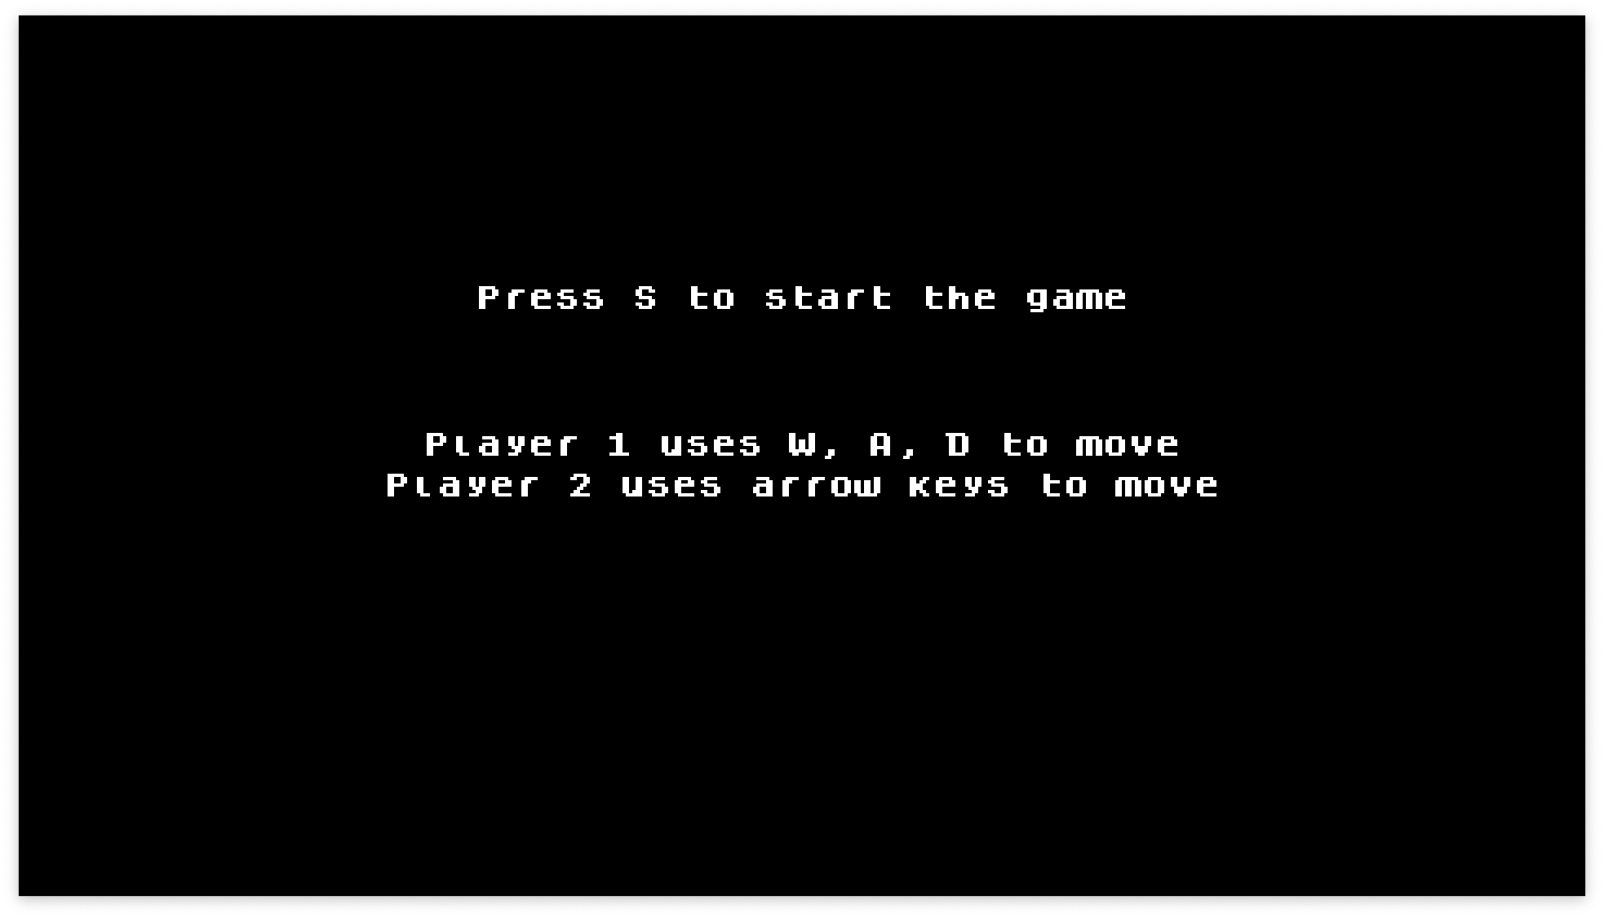

5.2 Enter the arena

5.2.1 Initial stage
When the game begins, a count down is shown to ready the players. After the countdown ends, the game officially starts.
Touching the outer lines of the arena does not harm the player. However, it does keep the player from going out of bounds. If the player touches their own tail, it will count as taking damage so be careful to not touch any of the characters’ lines.
As the game objective says, you now have to let the other player touch their own or your tail to win the round and decrease their health.
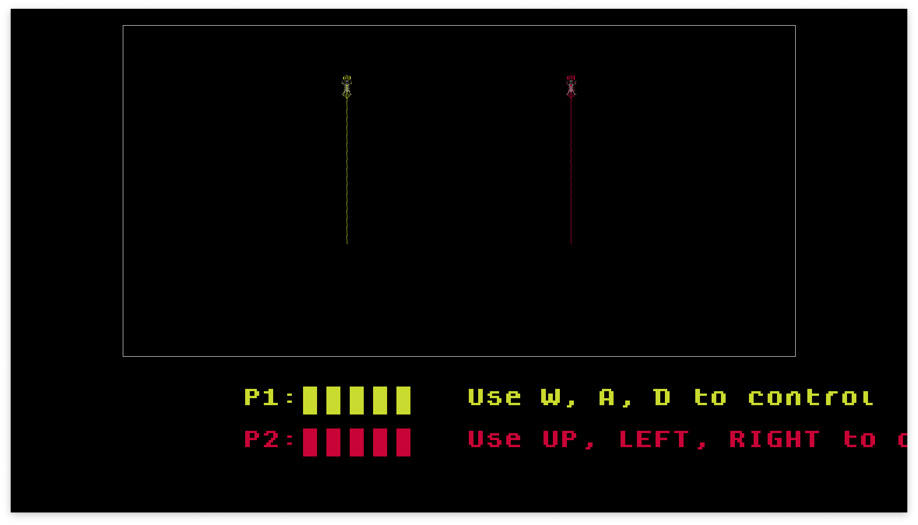

5.2.2 Sudden Death
If the players have a stalemate after 15 seconds the “Sudden Death” will start. When the sudden death happens, the arena will shrink from both sides so that the players will have to fight in more tight arena.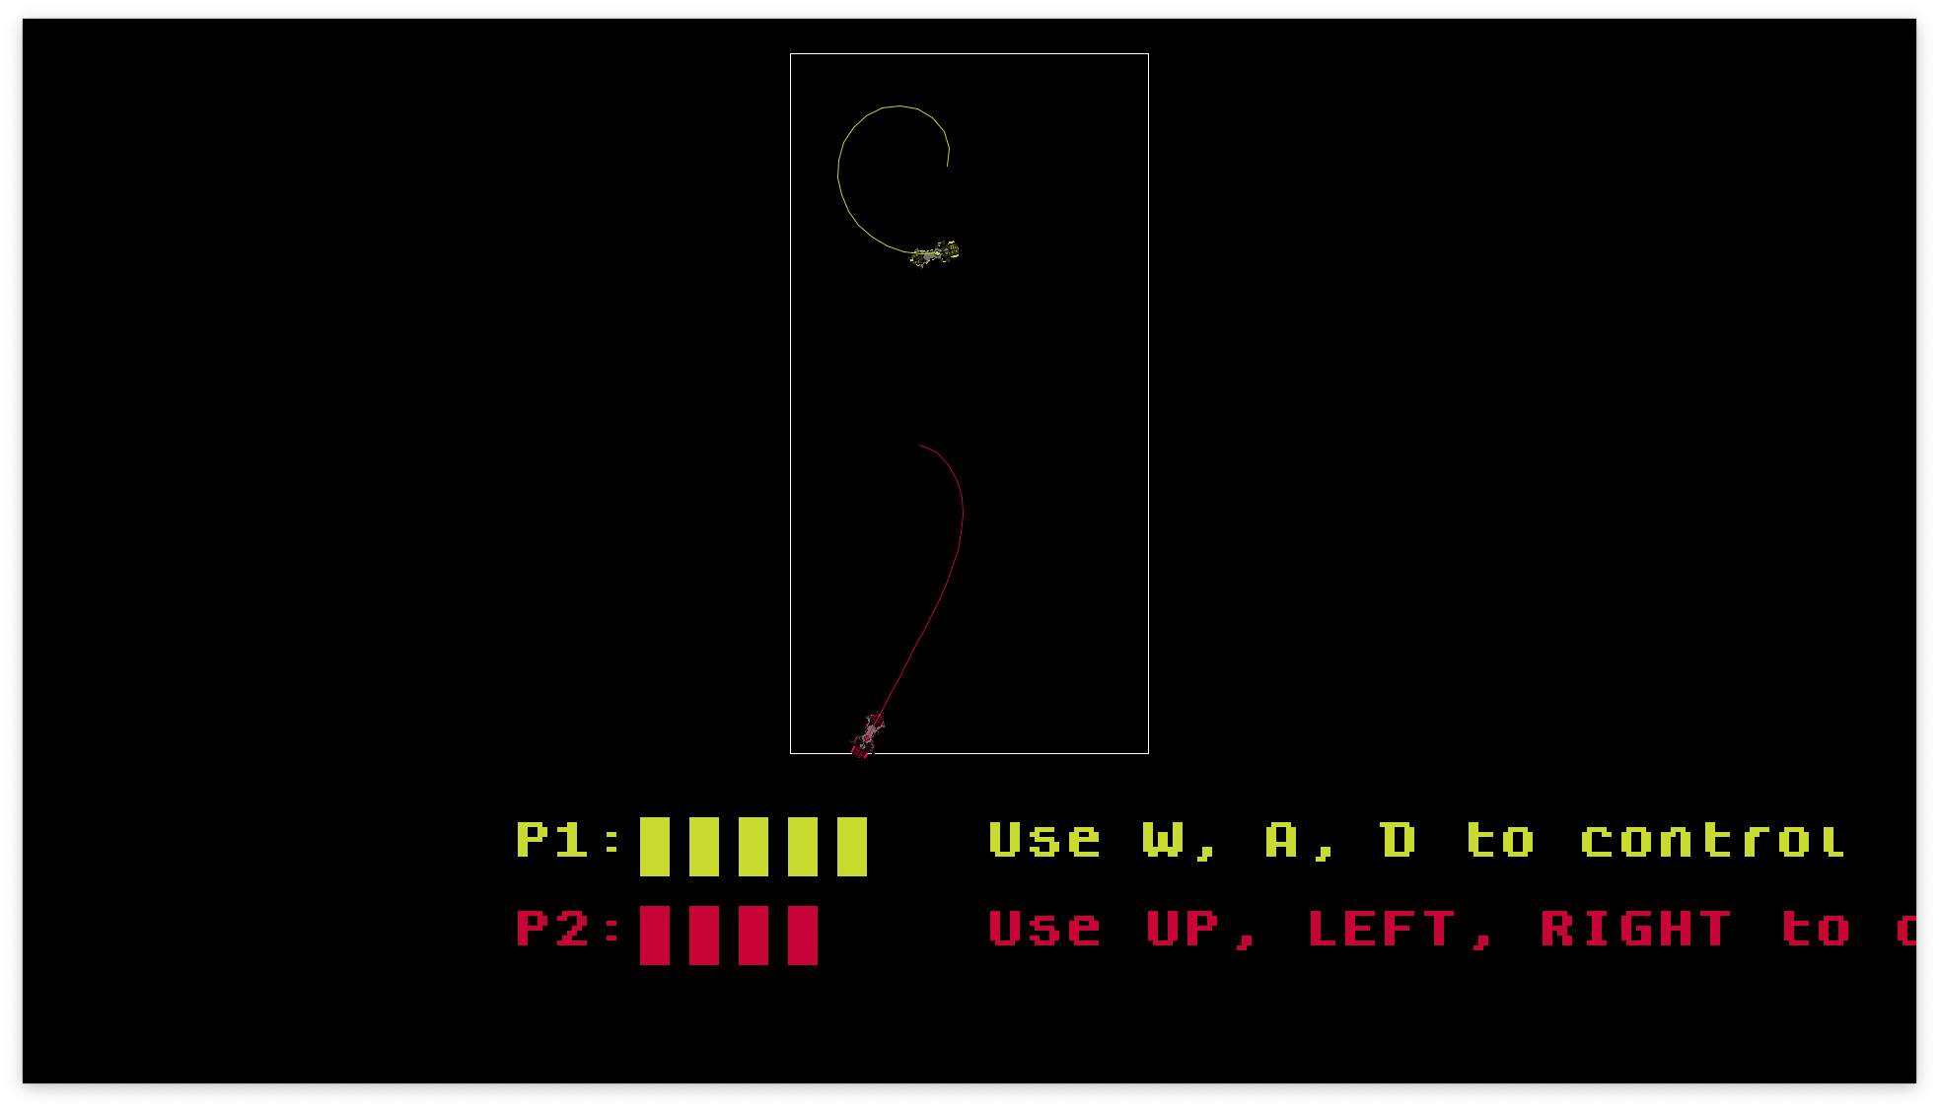

5.2.3 Endscreen
After either one of the players loses, a congratulations screen will be shows to the winning player.
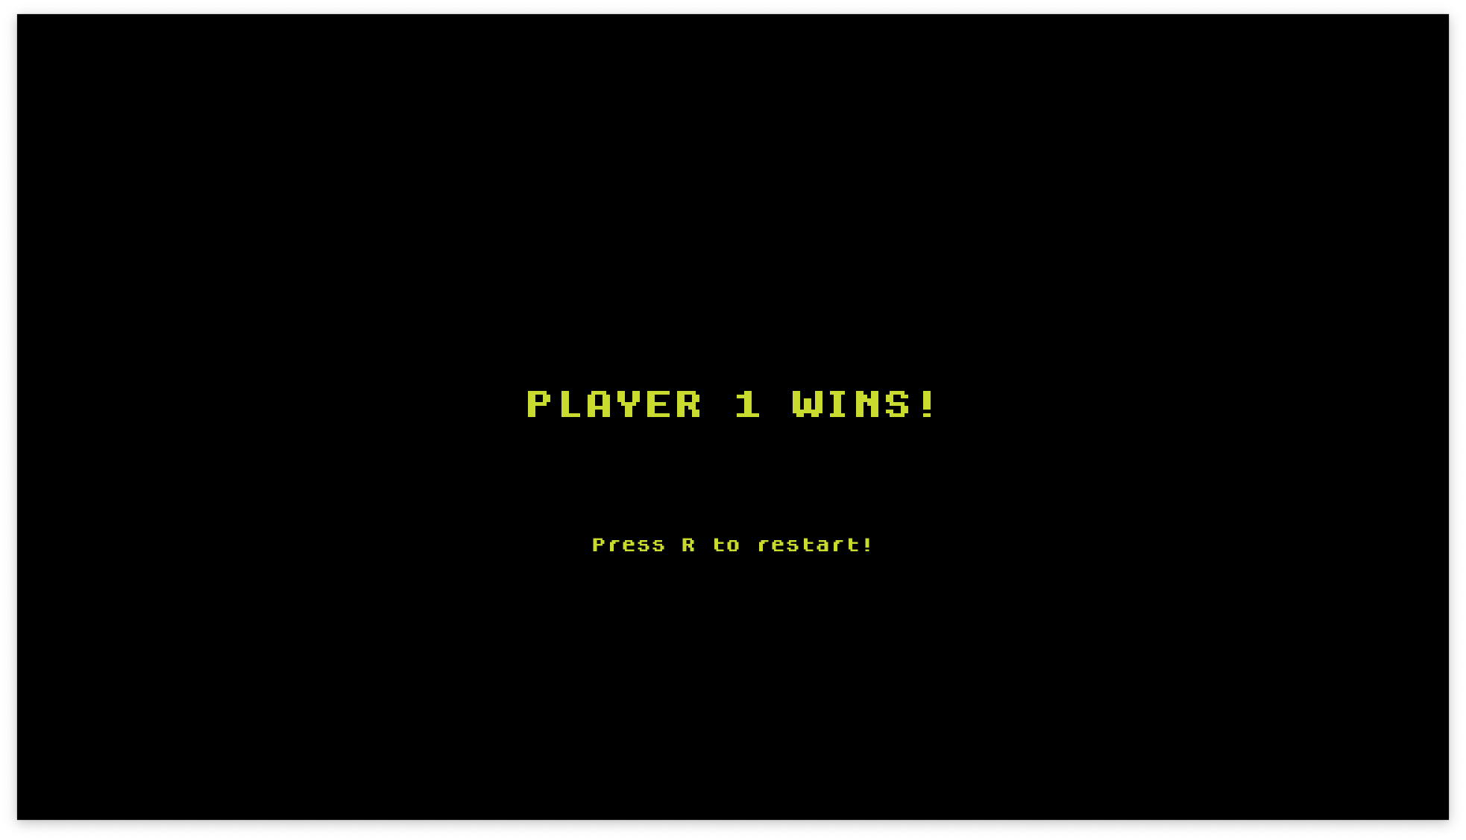
As you can see here, if you want to have a go at the game again, you can press ‘R’ to restart the game.

More about the Game
The game runs on Processing using java syntax. Because it is also part Java, we can create multithreaded games like this one.
The main UI thread is responsible for showing what is on screen to the players. This thread is mainly using the Nort.pde to draw the game on the screen.
Each player character has two threads each. One thread is for listening to the player’s keystrokes to ensure smooth controls to the player, and the other is for checking the collisions of the character.
In total there are 5 threads counting the UI thread and most of them run independently of each other.

7. Future development
In the future, the game could have developments such as:
- Leaving the bike trail in place so that it creates more obstacles in the area.
- Power up pellets randomly spawning.
- More than 2 player support.
- Better artstyle and audio queues

https://en.wikipedia.org/wiki/Tron

